**EE 602: Quiz**

Transmitter

Transmitter

Antenna

Receiver

Duplexer OR

T/R Switch

Receiver

Blanking Switch

*Fig.1 Monostatic Radar with Duplexer*

*Fig.2 Monostatic Radar with Circulator*

ON/OFF ratio of transmitter= 90 dB Duplexer isolation =50dB

Blanking Isolation=40dB Circulator isolation= 30 dB

**If any additional data/ conditions are required to reach the answer, Please mention clearly in the answer sheet.**

1. Pulsed radar operating at 2 GHz has a transmitter power 100 kW uses arrangement as shown in Fig.1 For this system to work satisfactorily, the specifications must be as follows:

Power input for receiver saturation : > ‘X’ dBm

Echo from the stationary targets : >’Y’ dBm, (to be detected)

Find the value of X and Y.

(a)-10, -100 (b) 0, 50m (c) -10, -60 (d)0, -80 … (1 mark)

1. What must be maximum distance between adjacent of a linear phased array so that the antenna pattern has a single main lobe. This means that the radiated power in no other direction the radiated power should be ‘almost-equal’ to the main lobe (no Grating lobe(s).). (Assume that the beam radiated in the direction perpendicular to the antenna array and it is not steered). For ‘radar in 1 and radar in 2’, The inter-element distance must be less than…… respectively.
2. 15 cm, 3 cm (b) 7.5 cm, 1.5 cm (c)15 sin(45)cm, 3sin(45)cm (d) 10.5cm, 2.1cm (1 mark)
3. A typical phase shifter is capable of introducing the phase shift of 00 to 3600. Such phase shifters are used to introduce the relative phase shift between the elements of linear antenna phased array operating in narrow band signal. Now, the calculations show that the required phase shift between the first element and the kth element is 4000. What is the simplest way of realizing this phase shift?
4. Two phase-shifters with phase shifts φ1+φ2 adding to 4000.
5. Phase shifter is configured for a phase shift of 400.
6. Phase shift 400 and piece of transmission line equivalent to the wavelength
7. Phase shifter is configured for 3200.

4. A pulsed radar uses 8 μs transmit pulse coded with 4 bit Barker code. Pulse Repetition Frequency (PRF) is 10 KHz, Peak power is 100 kW. What is the average transmit power and range resolution?

(a) 2 kW, 300m (b) 8 kW, 300m (c) 2 kW, 1200m (d) 8 W, 300m (1 mark)

Q2.

1. A radar transmits a frequency of ωR (= 1 GHz say). The schematic of the receiver is shown in the following figure. The LO frequency is 980 MHz, RF filter bandwidth is 980±30 MHz and IF filter bandwidth is 20±0.1 MHz.

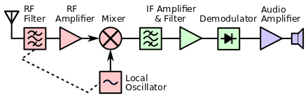

Echo processor

A signal @ 960 MHz from external source is received by the receiver. Will this signal conflict with the echo signal? (Answer Yes/ No with reasons) (1 mark)

1. If the RF Mixer in the receiver is replaced by the following arrangement. Will it make difference for the situation described in 3(i)? In the following diagram, the boxes with 900 indicate phase delay of 900). Write the values of the frequencies (not angular frequencies, in MHz) in the following diagram. (1 Marks)

Input 1 GHz:

Input 960 MHz:

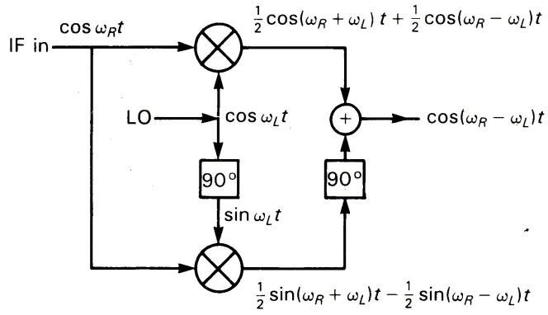

Input 1 GHz:

Input 960 MHz:

1. What will be the output in both the cases? For the system described in Q3 (ii)?

(1 mark)

**QUIZ-1 Answers**

1. **(c)**

100 kW= **80 dBm**, We compute the leakages during transmit and receive period

During transmission, **80-50-40=**-**10 dBm** (duplexer and blanking switch isolation) at the receiver,

So the receiver saturation level should be higher **0.5**

During receive, **80-90-50= -60 dBm.** (ON-OFF ratio and Duplexer isolation) This leakage appears as DC (zero Doppler) signal in the baseband. Hence genuine echo must be stronger 0.5

(Marks could be given even if only for the calculations are mentioned)

1. **(a)**

In the phased array, the main lobe is at 90 degrees to the axis the grating lobe start appearing along the axis (900 from the intended direction) if the radiations from adjacent elements add in phase. This happens when ‘**inter-element distance = λ’, for 2 GHz and 10 GHz, λ=15cm and 3 cm Respectively**

1. **(b)**

400 is equivalent to 4000 (as 400-360=40) degrees. Actual path difference is not important for beam forming. Just introduction of 40 is sufficient.

1. **(b)**

The radar has PRP of 100μs and transmit pulse time of 8 μs. Therefore the average power is 100X(8/100)= 8kW. And the resolution is corresponding to 2 μs, i.e. 300m.

Q2.

1. Yes. It will conflict with 1 GHz signal.

The signal at 960 MHz shall be passed through the filter and the mixer to give IF of 20 MHz. ( as there

1. Put ωR= 2π X1000MHz and 2π X960MHz (frequency value= 1000, 960), for two cases.

And ωL= 2π X980MHz (Frequency value 980)

Input 1 GHz: 1980 and 20

Input 960 MHz: 1960 and -20

Input 1 GHz: 1980 and 20

Input 960 MHz: 1960 and -20

First/ upper box 🡺

(0.5 mark)

Second/ Lower box

Input 1 GHz: 1980 and 20

Input 960 MHz: 1960 and -20

(0.5 mark)

(ii)Delay is mathematically represented by putting -900 in the phase.

* **-Sinθ** becomes **Cos θ** after the delay of 900.
* **Sinθ** becomes **-** **Cos θ** after the delay of 900

Output for 1000 MHz, the output is (1980 MHz terms have opposing signs) 20 MHz (0.5 mark)

Input 1 GHz: 1980 and 20

Input 960 MHz: 1960 and -20

And for 960 MHz, the output is zero (Both the terms add with opposite signs) (0.5 mark)